**Sprint 3 Manual Testing Report**

Team 18: Chunao Liu, Anurag Shah, Jenna Zhang, Yierpan Abuduwaili, Michelle He, Jingyuan Yang

**User Story #1: As a user, I would like to be able to update my account.**

* Test Case 1:

Input: Change username from “jack” to “jacky”

Output:

o Backend: sends response with success message

o Frontend: display a popup success message & username updated Acceptable? - Yes

* Test Case 2:

Input: Change email address from “jack@gmail.com” to “jacky@gmail.com”

Output:

o Backend: sends response with success message

o Frontend: display a popup success message & email address updated

Acceptable? - Yes

* Test Case 3:

Input: Change username from “jack” to “mandy”

Output:

o Backend: sends response with an error message

o Frontend: display a popup error message: “username is already in use”

Acceptable? - Yes

* Test Case 4:

Input: Change email from “jack@gmail.com” to “mandy@gmail.com”

Output:

o Backend: sends response with error message

o Frontend: display a popup error message: “email already in use”

Acceptable? - Yes

**User Story #2: As a user, I would like to be able to create/delete a team and add/remove a member if I am the team leader.**

* Test Case 1:

Input: Click “create Team” button

Output:

o Backend: sends response with success message

o Frontend: display a popup success message; a new group attached to the list.

Acceptable? - Yes

* Test Case 2:

Input: Click grey “delete team button”

Output:

o Backend: N/A

o Frontend: display a popup error message: “Only the group leader can delete this group!”

Acceptable? - Yes

* Test Case 3:

Input: Click Red “delete team button”

Output:

o Backend: sends response with a success message

o Frontend: display a popup error message: “Team successfully deleted”

Acceptable? - Yes

* Test Case 4:

Input: Click a team entry

Output:

o Backend: sends response with a group list

o Frontend: Redirect to a new page where all group members are displayed and the group leader is marked.

Acceptable? - Yes

* Test Case 5:

Input: Click grey “Add member” button

Output:

o Backend: N/A

o Frontend: display a popup error message: “Only the team leader can add people to the team!”.

Acceptable? - Yes

* Test Case 5:

Input: Click green “Add member” button

Output:

o Backend: sends response with a success message

o Frontend: display a popup success message: “New member added to the team”. && new member is attached to the team member list.

Acceptable? - Yes

* Test Case 6:

Input: Click Red “delete member button”

Output:

o Backend: sends response with a success message

o Frontend: display a popup success message: “Team member successfully removed from the team”

Acceptable? - Yes

* Test Case 7:

Input: Click grey “delete member button”

Output:

o Backend: N/A

o Frontend: display a popup error message: “Only the team leader can remove people from the group”.

Acceptable? - Yes

**User Story #4: As a user, I would like to see the detailed runtime error message or runtime output of the code written in the text editor.**

* Test Case 1:

Input:

#include <stdio.h>

int main() {

printf("Hello, World!")

return 0;

}

Output:

o Backend: sends response with error message

o Frontend: display the error message in red

Acceptable? - Yes

* Test Case 2:

Input:

#include <stdio.h>

int main() {

printf("Hello, World!");

return 0;

}

Output:

o Backend: sends response with output

o Frontend: display the output “Hello World!” in black

Acceptable? - Yes

* Test Case 3:

Input:

#include <stdio.h>

int main() {

int y = 10;

printf(“y: %d”, x);

return 0;

}

Output:

o Backend: sends response with error message

o Frontend: display the error message in red

Acceptable? - Yes

* Test Case 4:

Input:

#include <stdio.h>

int main() {

int x = 10;

printf(“x: %d”, x);

return 0;

}

Output:

o Backend: sends response with output

o Frontend: display the output “x: 10” in black

Acceptable? - Yes

**User Story #5: As a user, I would like to save the typed code into a specific group and name the code.**

* Test Case 1:

Input: user presses discard button

Output:

o Backend: N/A

o Frontend: the results will not be showed

Acceptable? - Yes

* Test Case 2:

Input: user presses save button

Output:

o Backend: N/A

o Frontend: shows modal with dropdown that let the user to choose a group

Acceptable? - Yes

* Test Case 3:

Input: user chooses a group and presses select button on group modal

Output:

o Backend: N/A

o Frontend: shows modal with text input that let the user to enter the name of the code

Acceptable? - Yes

* Test Case 4:

Input: user presses cancel button on group modal

Output:

o Backend: N/A

o Frontend: back to text editor page

Acceptable? - Yes

* Test Case 5:

Input: user enters a name and presses OK button on rename modal

Output:

o Backend: receives the code and saves it into the specified group

o Frontend: sends the code to backend with groupID and name; after receives response from backend, display saving success message

Acceptable? - Yes

* Test Case 6:

Input: user presses cancel button on rename modal

Output:

o Backend: N/A

o Frontend: back to text editor page

Acceptable? - Yes

**User Story #6: As a user, I would like to save the image result to a certain group library or discard the image.**

* Test Case 1:

Input: When not logged in, try saving function

Output:

o Backend: N/A

o Frontend: Save to local storage

Acceptable? - Yes

* Test Case 2:

Input: When logged in, try saving function

Output:

o Backend: Saves the image to certain group with the name that user typed

o Frontend: Prompts the user to rename the image and select a group to save

Acceptable? - Yes

* Test Case 3:

Input: Try login and logout, and do the saving function again

Output:

o Backend: Saves the image to certain group with the name that user typed when logged in, and local when not logged in

o Frontend: Prompts the user to rename the image and select a group to save when logged in, and saves the image directly to local when not logged in

Acceptable? - Yes

* Test Case 4:

Input: user presses cancel button on group modal

Output:

o Backend: N/A

o Frontend: back to Camera page

Acceptable? - Yes

* Test Case 5:

Input: user enters a name and presses OK button on rename modal

Output:

o Backend: receives the code and saves it into the specified group

o Frontend: sends the code to backend with groupID and name; after receives response from backend, display saving success message

Acceptable? - Yes

* Test Case 6:

Input: user presses cancel button on rename modal

Output:

o Backend: N/A

o Frontend: back to Camera page

Acceptable? - Yes

* Test Case 7:

Input: user presses discard button

Output:

o Backend: N/A

o Frontend: the results will not be showed

Acceptable? - Yes

**User Story #7 As a user, I would like to see the runtime result of the image code and have a pop up window for the errors.**

* Test Case 1:

Input: Try taking a picture, selecting a language and click accept (logged in)

Output:

o Backend: Receives picture and return the image result

o Frontend: Sends the image and displays the result with result pop ups and error messages

Acceptable? - Yes

* Test Case 2:

Input: Try taking a picture, selecting a language and click accept (logged out)

Output:

o Backend: Receives picture and return the image result

o Frontend: Sends the image and displays the result with result pop ups and error messages

Acceptable? - Yes

* Test Case 3:

Input: Click the image to see the error of the image code again

Output:

o Backend: N/A

o Frontend: Displays the ocr return(error result) again as a pop up window

Acceptable? - Yes

**User Story #8: As a developer, I would like to automatically integrate git’s most updated content and revert it if the build was not successful**

* Test Case 1:

Input: change the test_jenkins on github to see if Jenkins can wake up and attempt to build

Output:

o Backend:A record is left on the Jenkin’s manage panel and the server is updated with the latest content

o Frontend:N/A

Acceptable? - Yes

* Test Case 2:

Input: change the setting and add an invalid module

Output:

o Backend:A failed record is left on the Jenkin’s manage panel and the server is still running without interference

o Frontend:N/A

Acceptable? - Yes

**User Story #9 and #10 (same test cases)**

* All test cases for this portion are images. The goal is to ensure that the image produces the desired output. The test cases are located at WhiteBoard\Backend\OCR\images\tesseract_tests. Certain characters and font styles do fail the test case, but are maintained in the folder for future use. These test cases are manual, the main function inside ocr.py (in WhiteBoard\Backend\WhiteBoardBackEnd\API) has to be manually updated to run them.  
    
  As noted above, the expected output for each test case is the text in that image. The actual output varies as tesseract is not deterministic. An output is “acceptable” when very few characters are wrong.
* Test case 1:  
  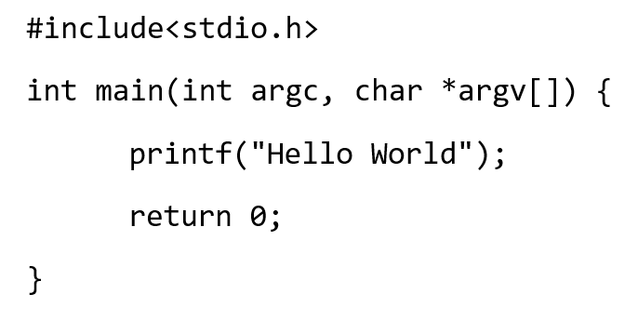  
  Acceptable: Yes
* Test case 2:  
  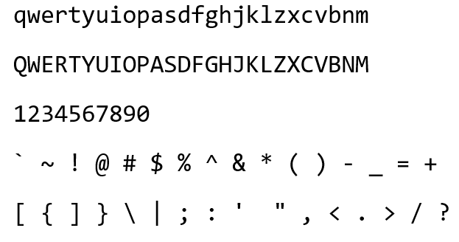  
  Acceptable: Yes
* Test case 3:  
  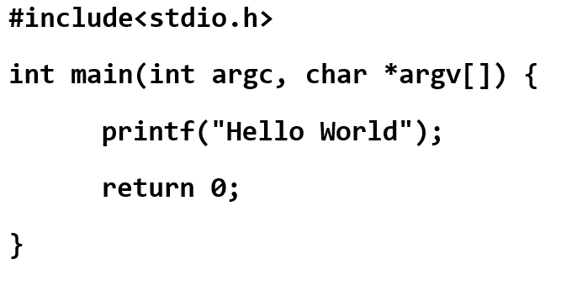  
  Acceptable: Yes
* Test case 4:  
  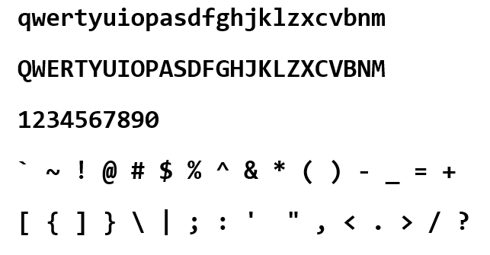  
  Acceptable: Yes
* Test case 5:  
  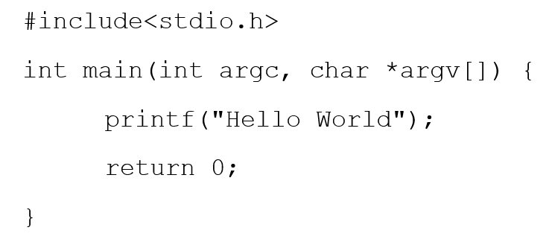  
  Acceptable: Yes
* Test case 6:  
  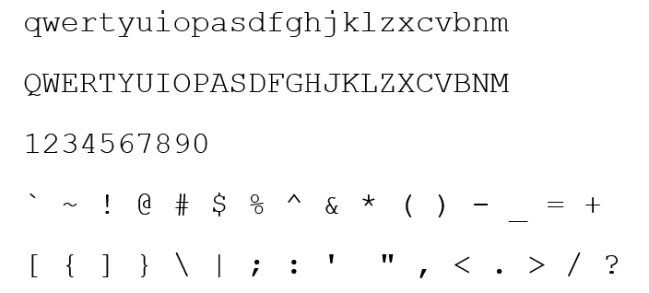  
  Acceptable: Yes
* Test case 7:  
  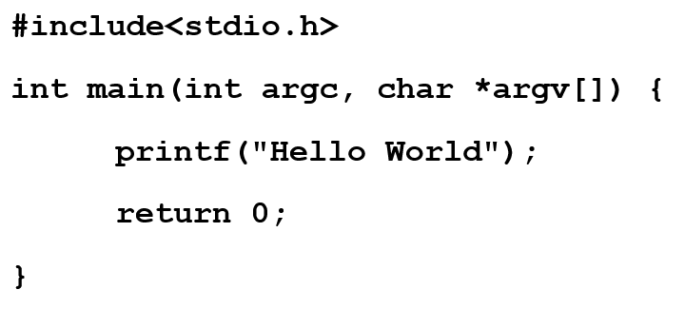  
  Acceptable: Yes
* Test case 8:  
  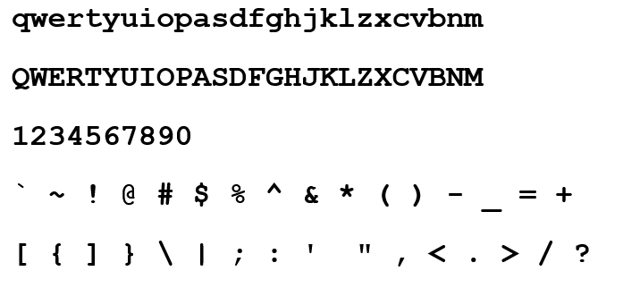  
  Acceptable: No
* Test case 9:  
  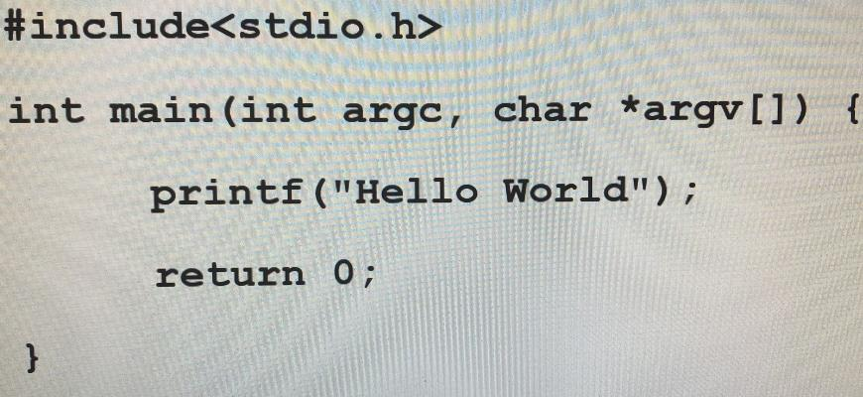  
  Acceptable: Yes
* Test case 10:  
  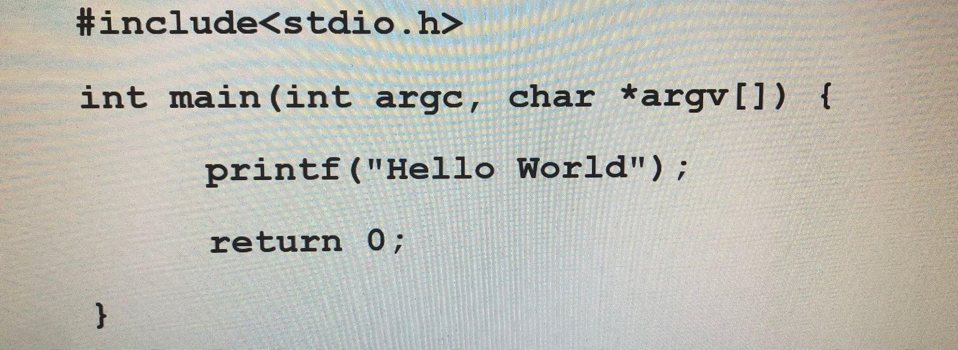  
  Acceptable: Yes
* Test case 11:  
  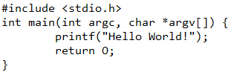  
  Acceptable: Yes
* Test case 12:  
  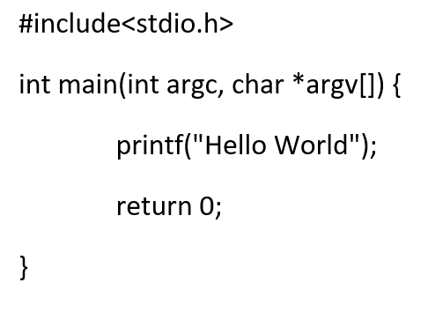  
  Acceptable: Yes
* Test case 13:  
  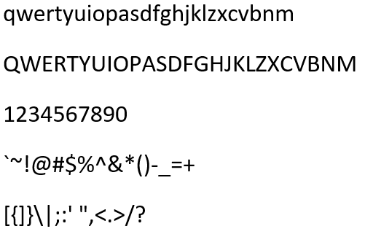  
  Acceptable: Yes
* Test case 14:  
  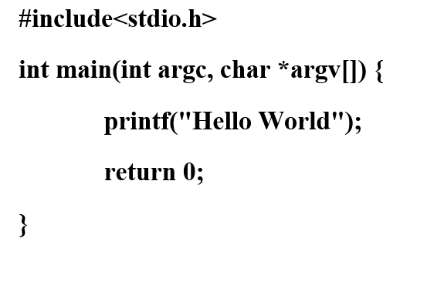  
  Acceptable: Yes
* Test case 15:  
  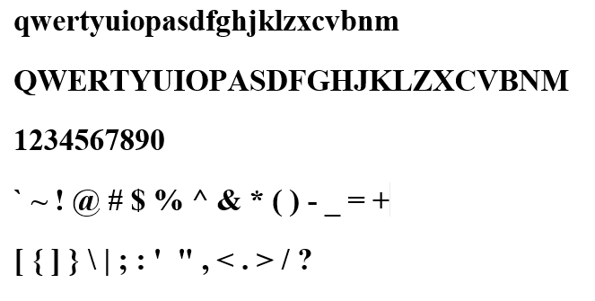  
  Acceptable: Yes

**User Story #12 and #13 (same test cases)**

* Test case 1:  
  Input: '#include<stdio.h>\n\nint main(int argc, char *argv[]) {\nprintf ("Hello World") ;\nreturn 0;\n\n}', "C"  
  Output: "Hello World"  
  Acceptable: Yes
* Test case 2:  
  Input: "#include <iostream>\nint main() {\nstd::cout << \"Hello World\";\nreturn 0;\n}", "C++"  
  Output: "Hello World"  
  Acceptable: Yes
* Test case 3:  
  Input: "namespace HelloWorld {\nclass Hello {\n static void Main(string[] args) {\nSystem.Console.WriteLine(\"Hello World\");\n}\n}\n}", "C#"  
  Output: "Hello World\n"  
  Acceptable: Yes
* Test case 4:  
  Input: '"class HelloWorld {\npublic static void main(String[] args) {\nSystem.out.println(\"Hello World\");\n}\n}", "Java"  
  Output: "Hello World\n"  
  Acceptable: Yes